Pauntley Parish Council
Asset Register as at 31 March 2022

Description | Date Acquired | Value | Custodian | Disposal
Wooden bus shelter | September 2009 | £2,760 (insurance value) | Parish Council
Telephone Kiosk Pool Hill  No 01531820415 | 22.2.2010 | £1.00 (purchase cost from BT) | Parish Council
Telephone Kiosk Brand Green  No 01531820421 | 22.2.2010 | £1.00 (purchase cost from BT) | Parish Council
Defibrillator Pool Hill telephone kiosk. Powerheart G5  Serial No M00000013517 and cabinet | 9.9.2015 | £1,860 (purchase cost from Community Heartbeat) | Parish Council
Defibrillator Brand Green  Zoll AED Plus  Serial No X15L801076 and cabinet | 18.11.2015 | Donation from British Heart Foundation – purchase value approx. £1,764. | Parish Council
Notice board Ketford – wood with wooden posts | 2000 | Donation from local resident | Parish Council
Notice board Pool Hill - wood | Unknown | Donation from local resident | Parish Council
Notice board Village Hall – wood with metal posts | Unknown | Unknown | Parish Council
Notice board Compton Green bus shelter – wood frame | 2009 | £50 | Parish Council

Total assets as at 31.3.22 £ 6,436.00

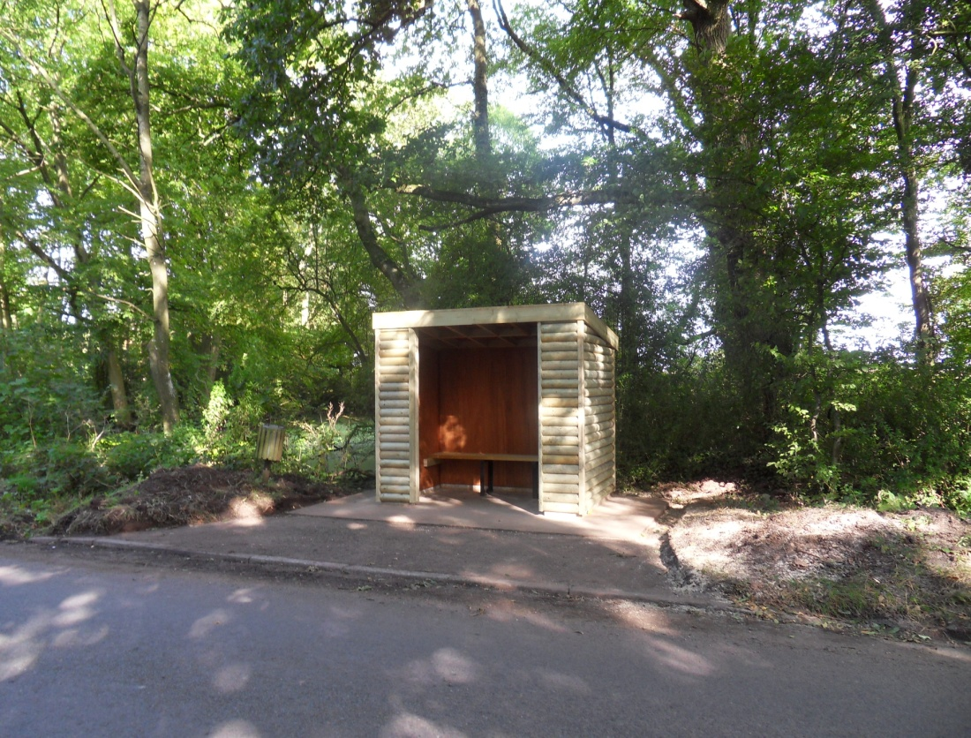

Bus Shelter at Compton Green
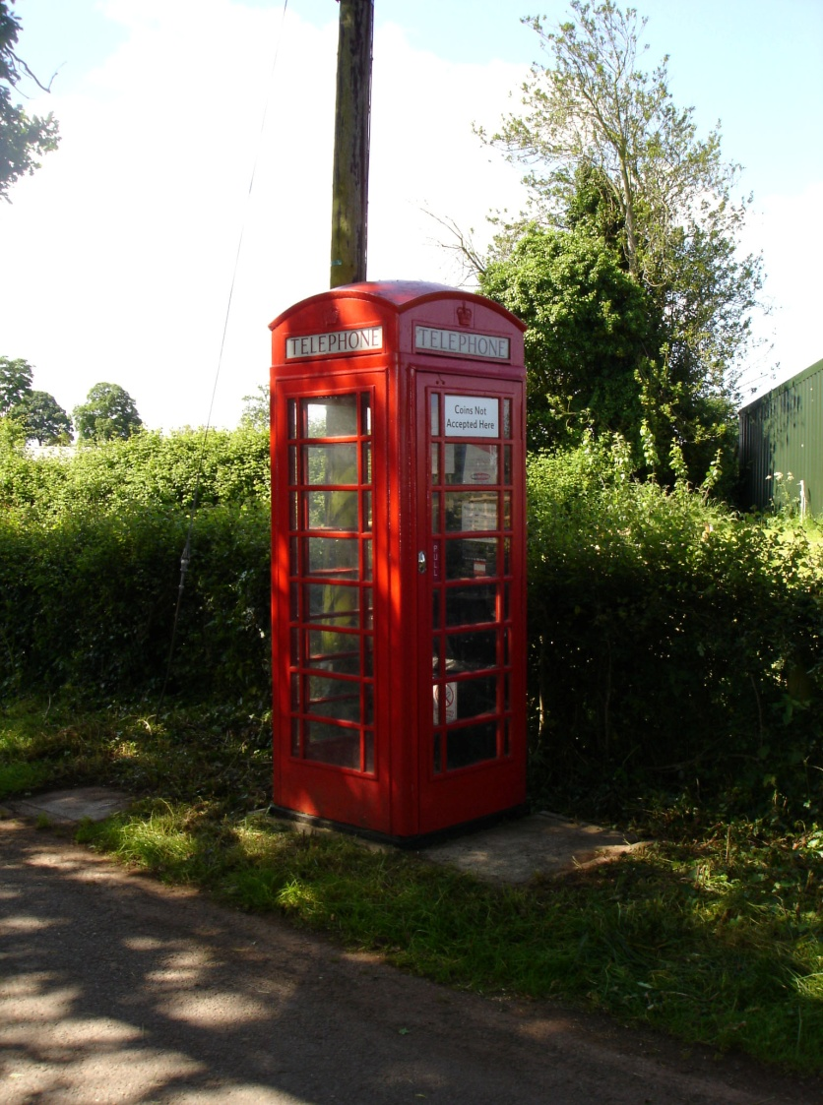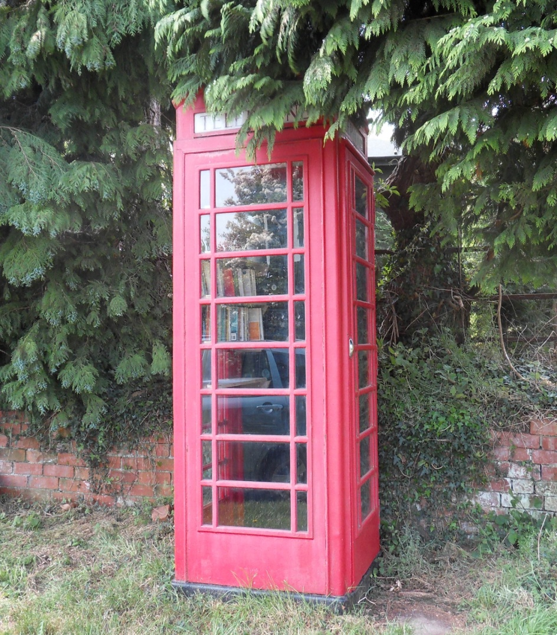

Telephone kiosk at Pool Hill Telephone Kiosk at Brand Green

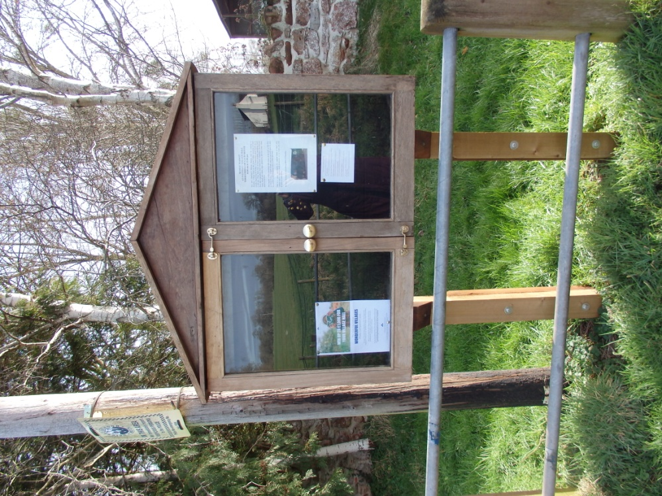
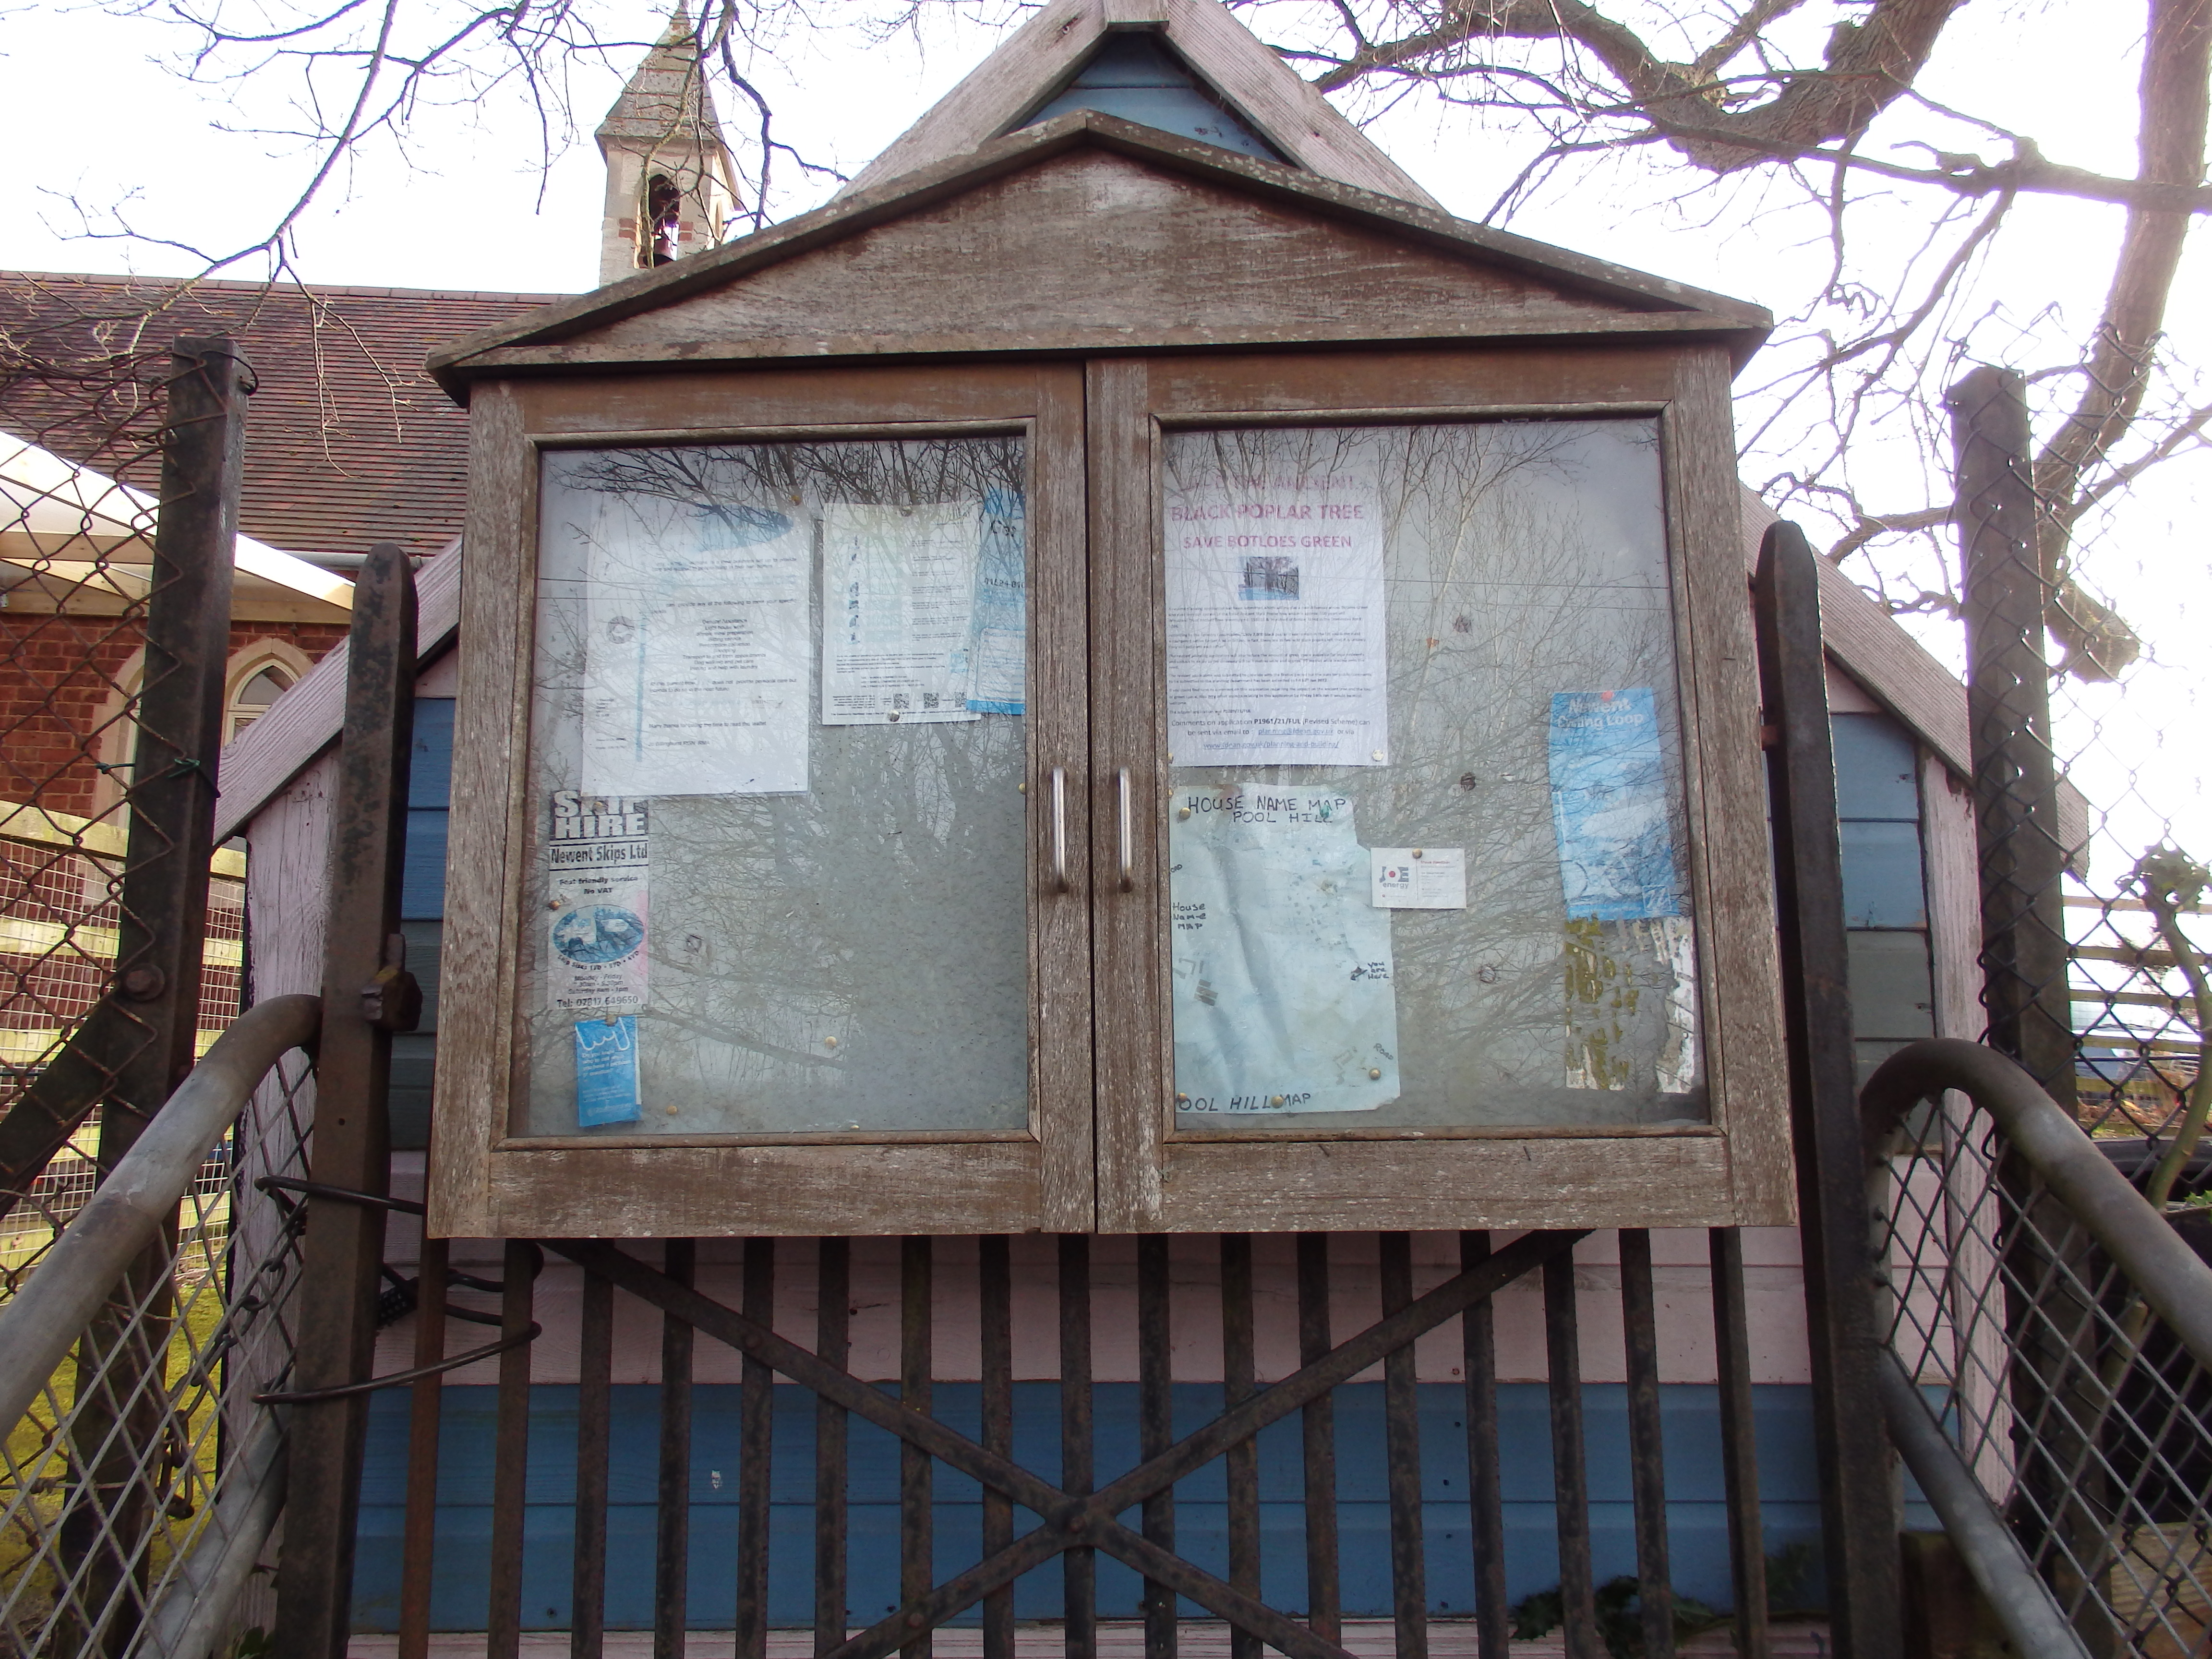

Notice board at Ketford Notice board at Pool Hill

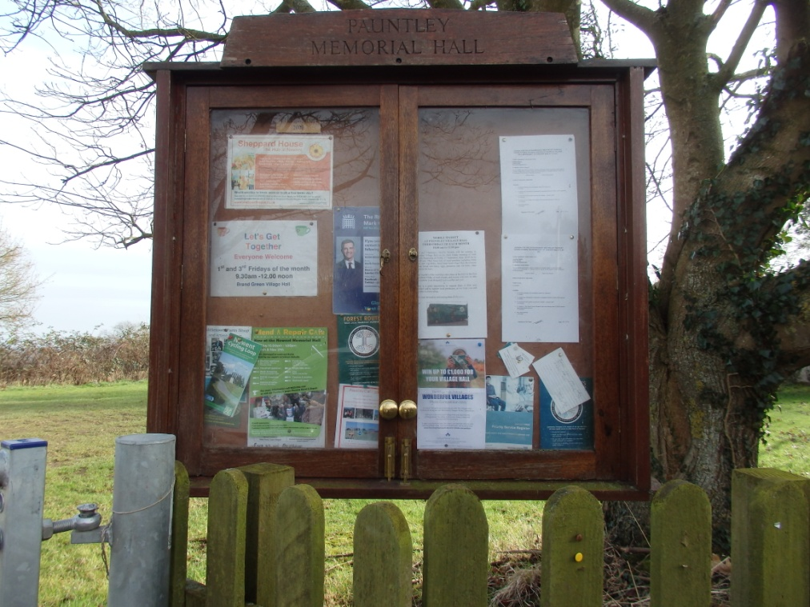

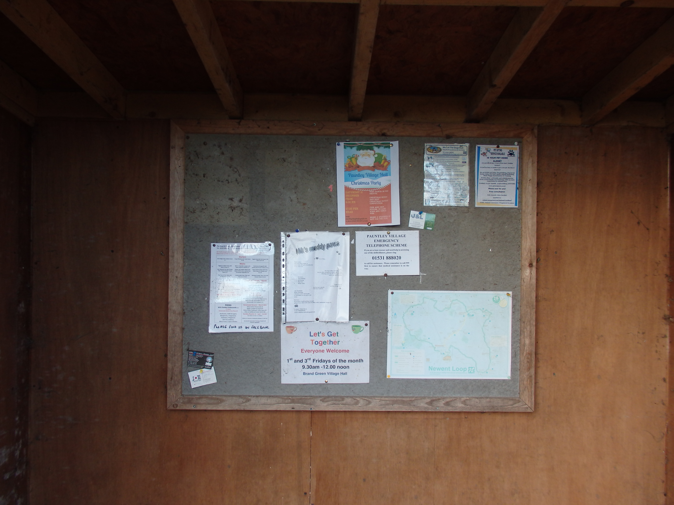

Notice board at Pauntley Village Hall Notice board in Compton Green bus shelter

Charity Assets held by the Council as Trustee

Description | Date Acquired | Value | Custodian | Disposal
Pauntley Village Hall | 20.2.2009 | £342,555 (insurance value) | Parish Council as Sole Trustee of Pauntley Village Hall

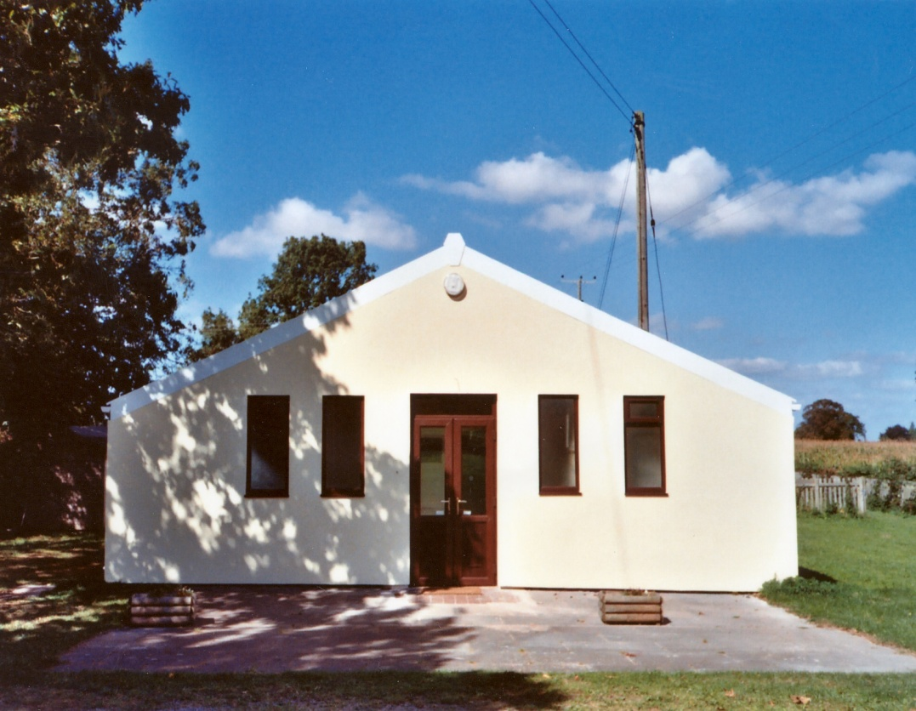

Pauntley Village Hall

